Draw or print a 15 by 15 multiplication square.

Pick any 2 by 2 square and add the numbers on each diagonal.
For example, if you take:
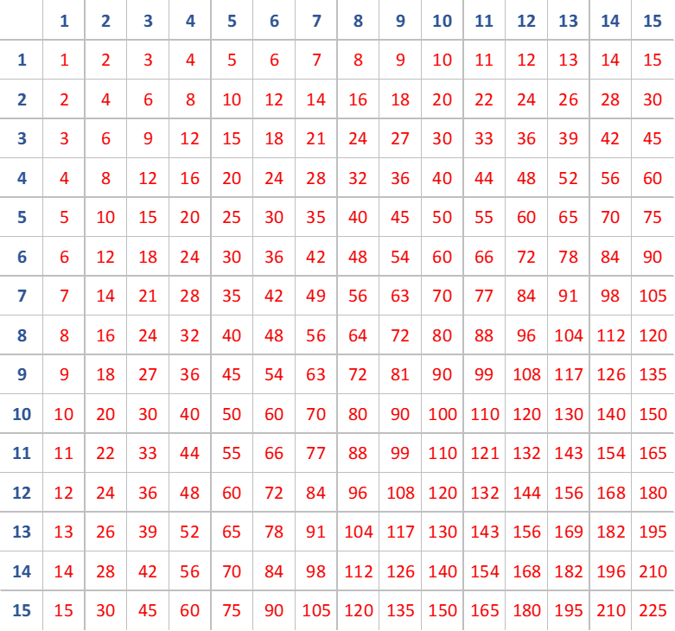

the numbers along one diagonal add up to 77 (32+45) and the numbers along the other diagonal add up to 76 (36+40).

Try a few more examples.
What do you notice?
Can you show (prove) that this will always be true?

Now pick any 3 by 3 square and add the numbers on each diagonal.
For example, if you take:

the numbers along one diagonal add up to 275 (72+91+112) and the numbers along the other diagonal add up to 271 (84+91+96).

Try a few more examples.
What do you notice this time?
Can you show (prove) that this will always be true?

Now pick any 4 by 4 square and add the numbers on each diagonal. Try a few examples.
What do you notice now?
Can you show (prove) that this will always be true?

Can you predict what will happen if you pick a 5 by 5 square, a 6 by 6 square ... an n by n square, and add the numbers on each diagonal?

Can you prove your prediction?

